Installation notes:

Step 1.
Create a virtual directory named ASPApplication following the steps below:

Step 1.1.
Go to Start -> Settings -> Control Panel -> Administrative Tools -> Internet Services Manager

Step 1.2
In the Internet Services Manager window right-click on the Default Web Site and select New and then Virtual Directory to start the wizard as shown in Figure 1.

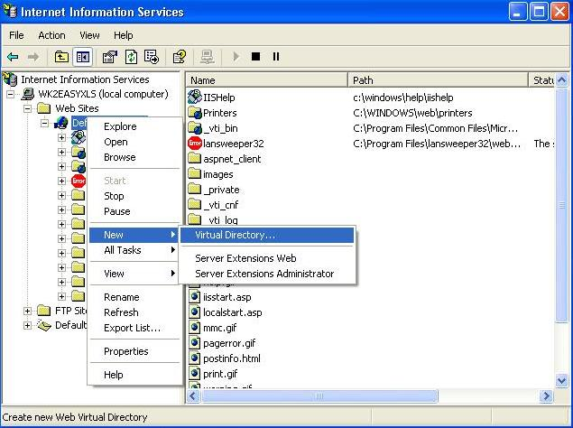

Figure 1

Step 1.3
In the Alias field enter the name of the application: ASPApplication as shown in Figure 2 and click Next.

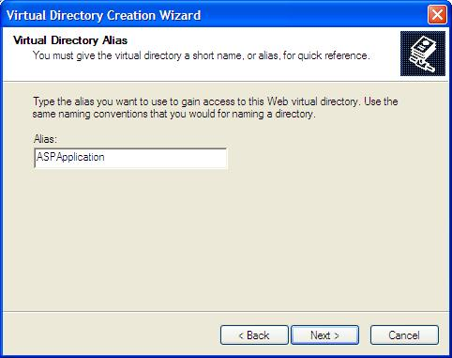

Figure 2

Step 1.4
In the Directory field enter (or browse to) the full path to the directory where the application has been installed ( e.g. C:\Program Files\EU Outsourcing\EasyXLS Trial for .NET v8.0\COM+ version\Project Tutorials\ASPApplication ) and click Next.
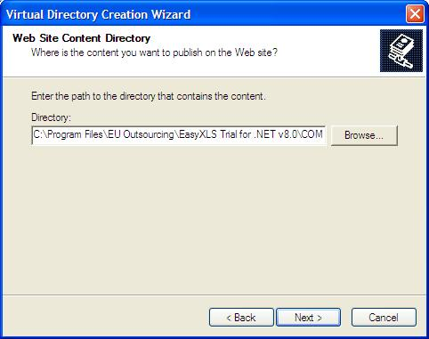

Figure 3

Step 1.5
- In the access permissions panel make sure that the following two items have check-marks next to them:
  - Read
  - Run scripts
and click on Next and Finish buttons.
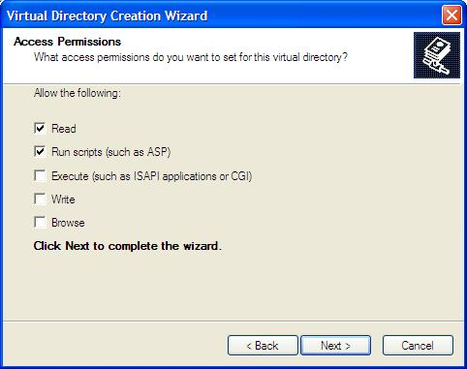
Figure 4

Step 1.6
When you're done you should see the new virtual directory listed under the Default Web Site. Right-click on this new virtual directory and select Properties and you should have the following:

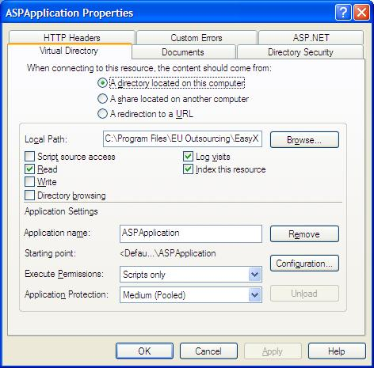

Figure 5

Step2.
In the Internet browser window type:

Figure 6

